Create the Static website from git repo mentioned below <https://github.com/devopsdec24/python-reach-sample.git>

Cloned the repo and made the containers up

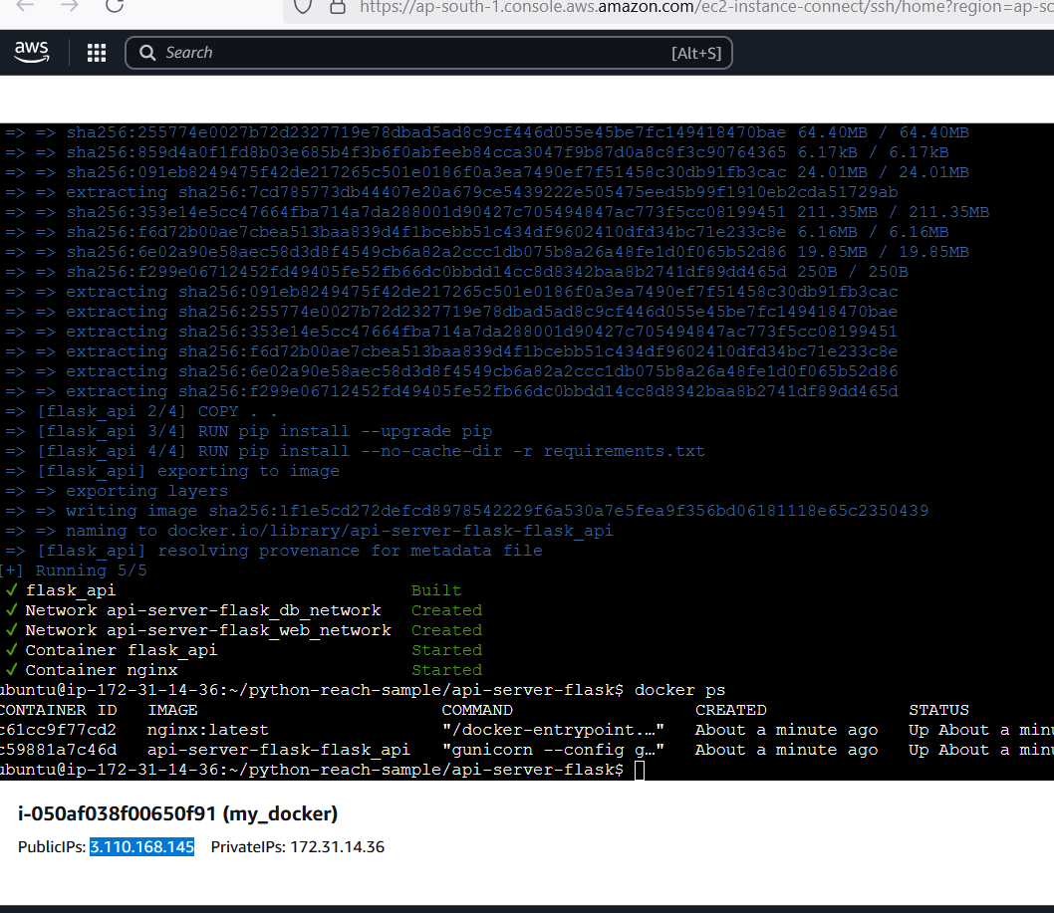

Edited config file in src to change the public ip and port number

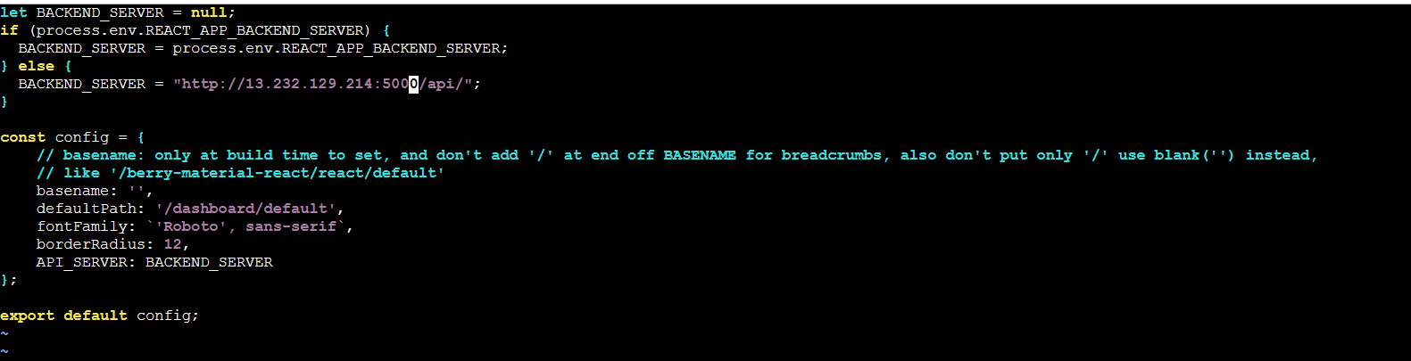

API created

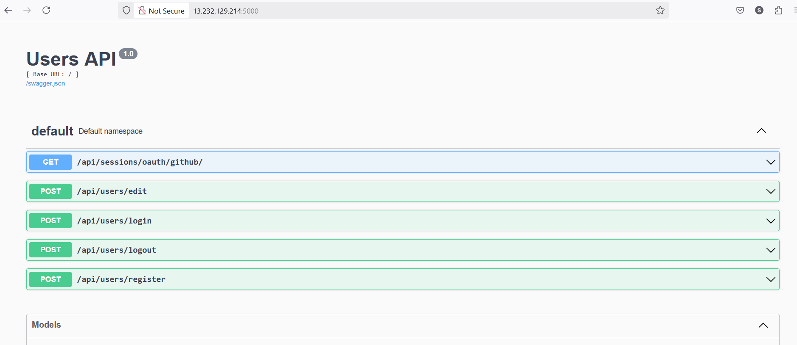

UI app :

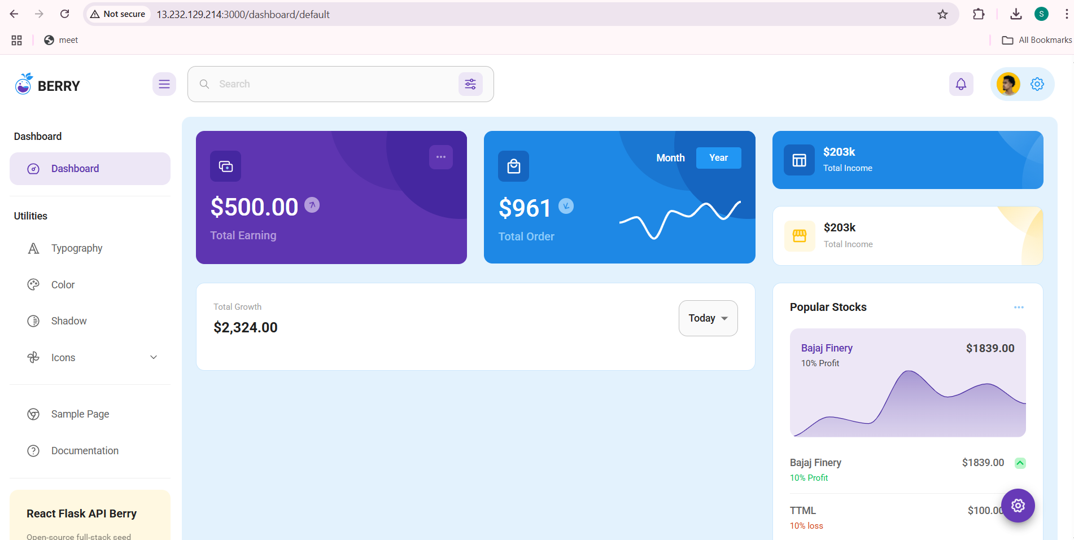

Created LB :

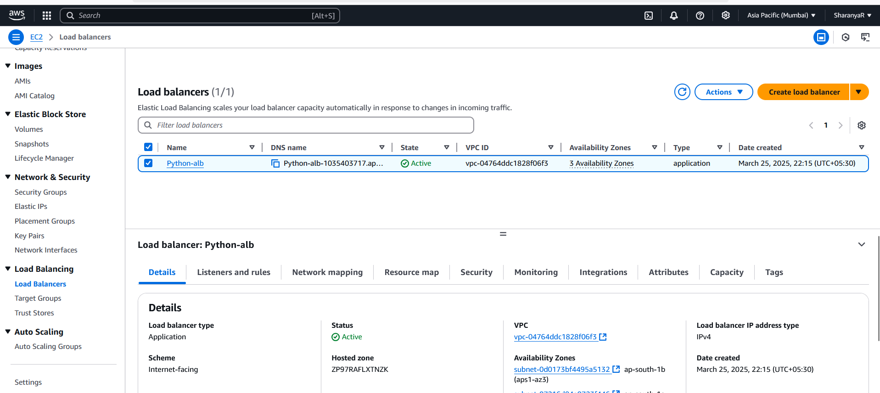

Set target groups:

